ITWS-1100

9 March 2024

[**College Exam Hub Project Plan**](https://docs.google.com/spreadsheets/d/1tKdrD-FlgixCQgAnUaI6bJCn1dcwOi6Fa_AQjPTQKIA/edit?usp=sharing)

Felipe Alves, Joseph Fodera, Alex Kuang

***Project Overview:***College Exam Hub is meant to be an RPI-specific web application, with the possibility of being extensible to more colleges given more in-depth development. Its purpose is to make it easier to search for/access back exams for courses at RPI by taking advantage of already present back exams along with one's contributed by the users. This application basically allows any user with a valid RPI email (in which you confirm on the application) to upload a pdf of a back exam to any course they want. Also, if the user has confirmed their address, they can leave comments, ratings, and even report an exam for either not being an exam or not being in the right course. A school email is not necessary if you just want to view/download any exam.

***Changes****:*

* Areas of Focus:
  + Our original areas were Area 1-HTML/CSS and Area 5-putting real data into the database. Our new ones are:
* Primary: Area 1 - HTML, CSS, and graphics for page layout and design (remains the same)
* Secondary: Area 2 - Javascript interactivity to improve user experience (what we changed to)
  + Our switch from area 5 to area 2 was influenced by actually mapping out our prototype website in lab 7, along with what we have learned in class since our original proposal. We all feel more comfortable with Javascript than managing online databases, because we have covered it more in depth in class. Also, when mapping, we found a lot of areas in which Javascript implementation would greatly improve the user experience such as drag and drop, alerts based on user interaction,
* Target Audience:
  + In our original project proposal, our intended target audience was for college students in general, but we are reducing the scope of our project so that the target audience is for students and TAs at RPI because we believe creating our project with the original target audience in mind would have been too ambitious; we would not be able to make enough progress to make something presentable and functional enough by the final deadline. Additionally, we may not have the resources to do this, and focusing on a smaller scope will be beneficial in the long run since we would be able to better understand how our project would work.
* View Exam Page Layout:
  + In our original wireframe layout, we had two separate buttons on the view exam page, one that would take you to a 'comments' page and another that would take you to a 'Questions/Discussions' page. We determined that having both of these was redundant and decided to merge them into one 'comments' page. On this page, users that have confirmed their email can make comments about the specific exam file.
  + When originally laying out our project, we knew we were going to need some sort of rating system and were originally leaning towards implementing upvotes and downvotes. After some discussion, we determined that a 5-star rating being given by the confirmed users would be more beneficial and descriptive while still being fairly simple
* IA Changes:
  + Added a confirm email page with CSS and Javascript so the user can type in their email and confirm their email to be able to make contributions. We thought it was better to add this page to the website so it could be cleaner and prevent the page from being too crowded with information.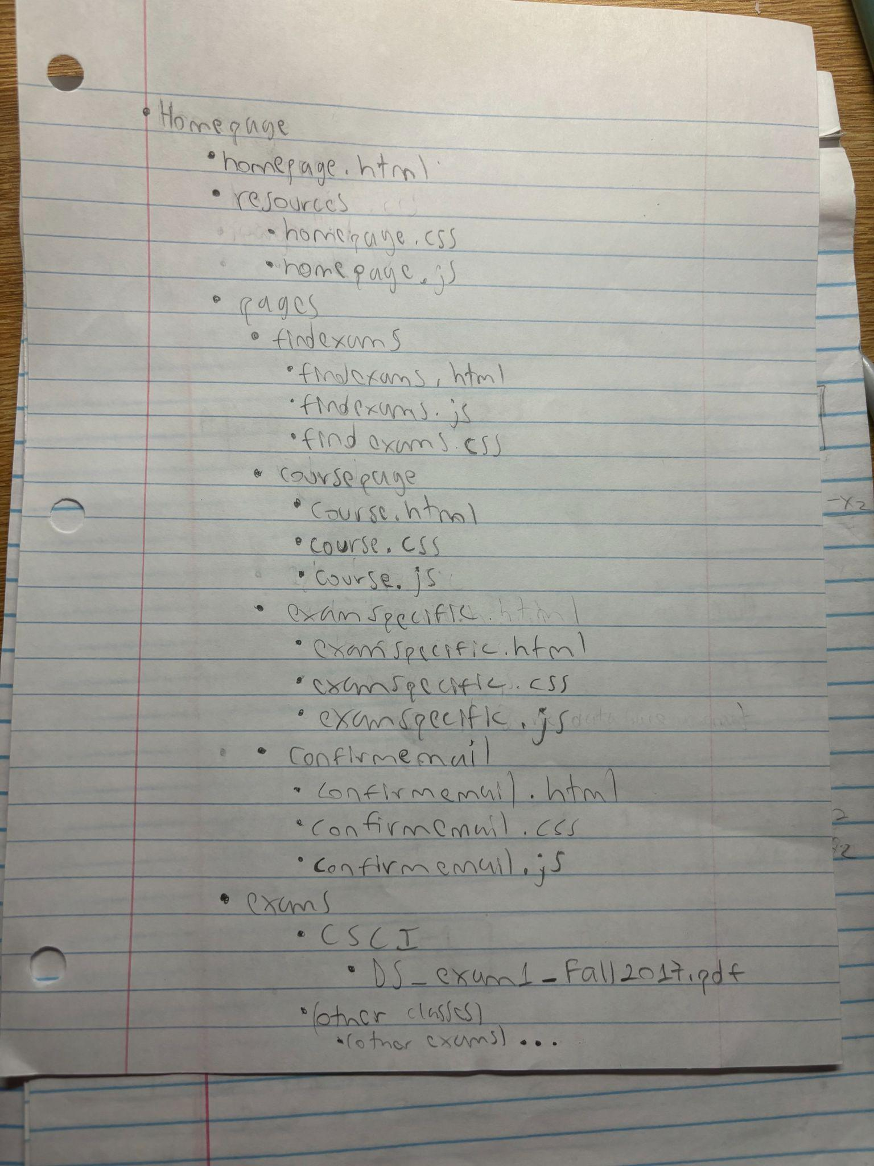
  + Removed the database file from the examspecific folder because we figured that Javascript would be able to cover all the things we were expecting to do using a database, so we chose to remove that to make things simpler.
  + Added an exams folder with each specific course code (potentially taken from SIS) and their exam so it can be easier to store and retrieve exams from one single directory, and to make it more organized.

**[Our Gantt Chart:](https://docs.google.com/spreadsheets/d/1tKdrD-FlgixCQgAnUaI6bJCn1dcwOi6Fa_AQjPTQKIA/edit?usp=sharing)**

<https://docs.google.com/spreadsheets/d/1tKdrD-FlgixCQgAnUaI6bJCn1dcwOi6Fa_AQjPTQKIA/edit?usp=sharing>

**New Notes/additions**

* crush exam day is our logo
* Drop file function makes new landing page for the file

We want javascript functionality where we select the class we want to drop the file to and then when we drop it, it launches a new page in HTML for theat specific file using an HTML Template

added course selector for drag and drop page in balsamic

JavaScript functionality is search bar